Johnny Li

EEL3111C

Tuesday P.10-11

Lab 6-Write Up

Introduction

The goal of this lab is to explore op amps and their different applications and forms. Multiple op amps were simulated throughout the lab, building upon each other to create more complicated circuits, to demonstrate different function. One design showed level shifting at works and another showed a differential circuit. A physical model was constructed to demonstrates the variations in a physical design.

Discussion

6.6.1 Construction

Figure 1: Circuit from Section 6.5.2 Item 5. Set Wavegen1, VIN, to a sinewave with a 5 V amplitude, 0 V offset, and a frequency of 1 kHz.

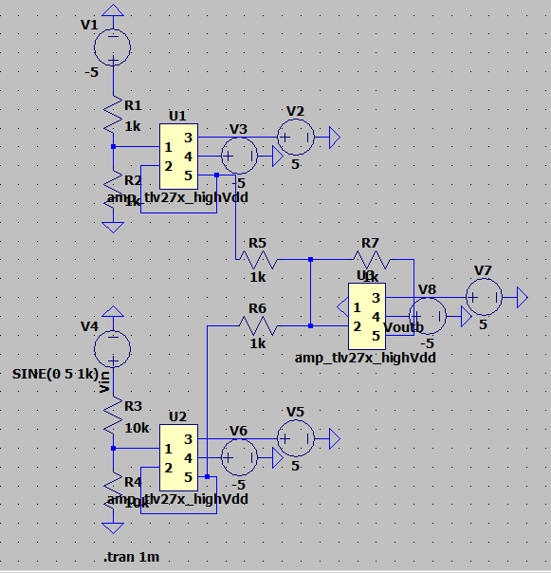

Figure 2: Plot of the input (blue) and output (orange) voltages of physical circuit from Section 6.5.2 Item 5.

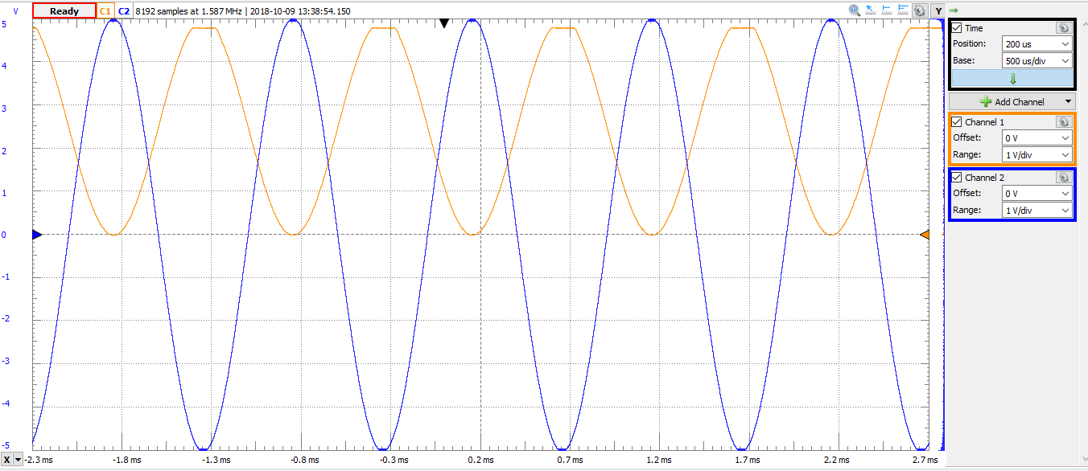

The circuit in Figure 1 has three different op amps with a range of +5V to -5V. One amp

takes in a set -2.5V due and outputs -2.5V to the final op amp. Another op amp takes in a user set

voltage, which we set to be an alternating sine wave, which is halved before going into this amp

and then being outputted to the final op amp. The set -2.5V by the first op amp is then used by

the last op amp to shift the range of its output from -2.5V : +2.5V to 0V : +5V as shown in

Figure 2. Resistor tolerances could cause the output to be less than the expected range of 0V :

+5V.

The circuit in Figure 1 has three different op amps with a range of +5V to -5V. One amp

takes in a set -2.5V due and outputs -2.5V to the final op amp. Another op amp takes in a user set

voltage, which we set to be an alternating sine wave, which is halved before going into this amp

and then being outputted to the final op amp. The set -2.5V by the first op amp is then used by

the last op amp to shift the range of its output from -2.5V : +2.5V to 0V : +5V as shown in

Figure 2. Resistor tolerances could cause the output to be less than the expected range of 0V :

+5V.

The circuit in Figure 1 contains three different op amps with a range of +5V to -5V. The top amp takes in -5V but is halved so the outputs is -2.5V. The bottom op amp takes in a defined voltage from the user, a sine wave, which would be halved before going into this amp and then being outputted to the final op amp. With the input set at -2.5V by the top op amp, the middle op amp shifts the range of its output from (-2.5V, +2.5V) to (0V, +5V) as shown in Figure 2. From Figure 2, output is less than the expected range of 0V to +5V because in a physical design the resistors are not ideal and that the tolerances causes deviations in the minimum and maximum voltages.

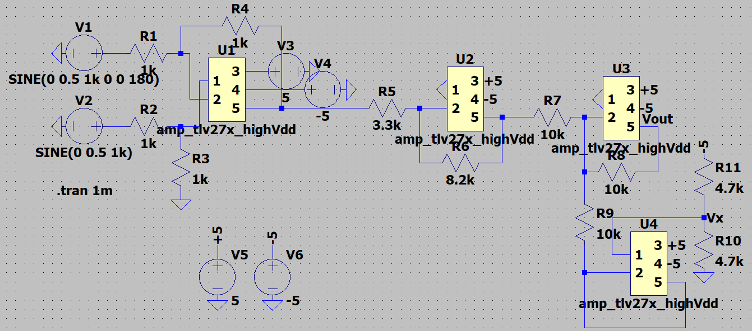Figure 3: Circuit from Section 6.6 (b). Set VIN1 to a sine wave with a 0 V DC offset, 0.5 V amplitude, and a 1k Hz frequency. Set VIN2 to a sine wave with a 0 V DC offset, 0.5 V amplitude, a 1k Hz frequency, and a phase of 180 degrees.

Figure 4: Plot of the input (blue) and output (orange) voltages of physical circuit from Section 6.6 (b).

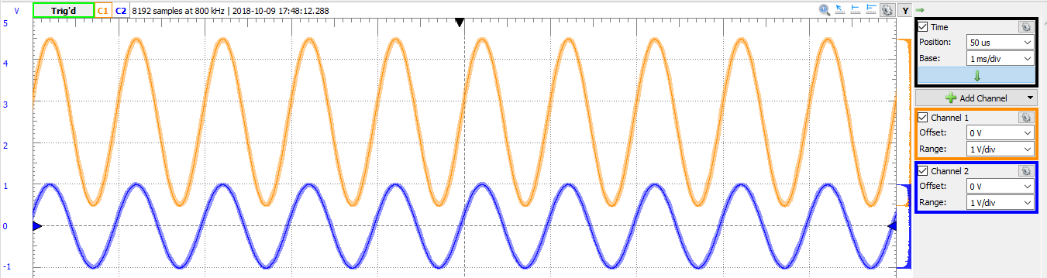

The circuit in Figure 3 consists of four op amps, three of them are in the same design as in Figure 1 and serve the same purpose, shifting the output range. The new op amp, takes in two user defined voltages, sine waves one of which was 180 degrees out of phase. Because the sine waves were out of phase, the inputs were added together to double the effective output. This voltage is then multiplied by the amp and then sent to the final amp where it’s voltage range is then shifted from (-2.5V, 2.5V) to (0V, +5V) as shown in Figure 4. From Figure 4, output is less than the expected range of 0V to +5V because in a physical design the resistors are not ideal and that the tolerances causes deviations in the minimum and maximum voltages. From Figure 3, the resistors R1 and R2 are in a voltage divider where they could be any value as long as they are equal value. R3,4, and 5 are in a differential op amp where they can also be any value as long as they are equal value, have to be greater than 470 ohms, so that the voltage output would be halve the input voltage. R6 and R7 needs to convert to a gain of 2.2 which can be set with R6 = 2.2k ohms and R7 = 1k ohms. The resistors value of the final op amp is predetermining in the lab manual, being 1k.

Conclusion

In conclusion, op amps have a wide range of applications from an op amp that add different voltages together to shifting the voltage range. For more complex design, more op amps are required and planning needed. While a physical op amp has inevitable human and mechanical error within the circuit design that influences the resulting values.